Class 6

Establish a new directory, populate it with script files, initiate an empty repository on GitHub, convert the local directory into a Git repository, and link it to GitHub to push the code into the repository.

1. Establish new directory

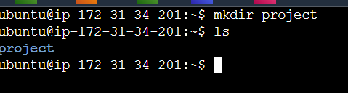

1. populate it with script files

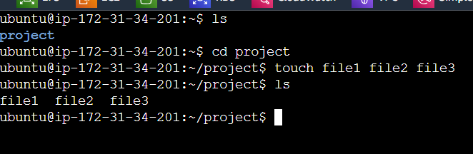

1. initiate an empty repository on GitHub,

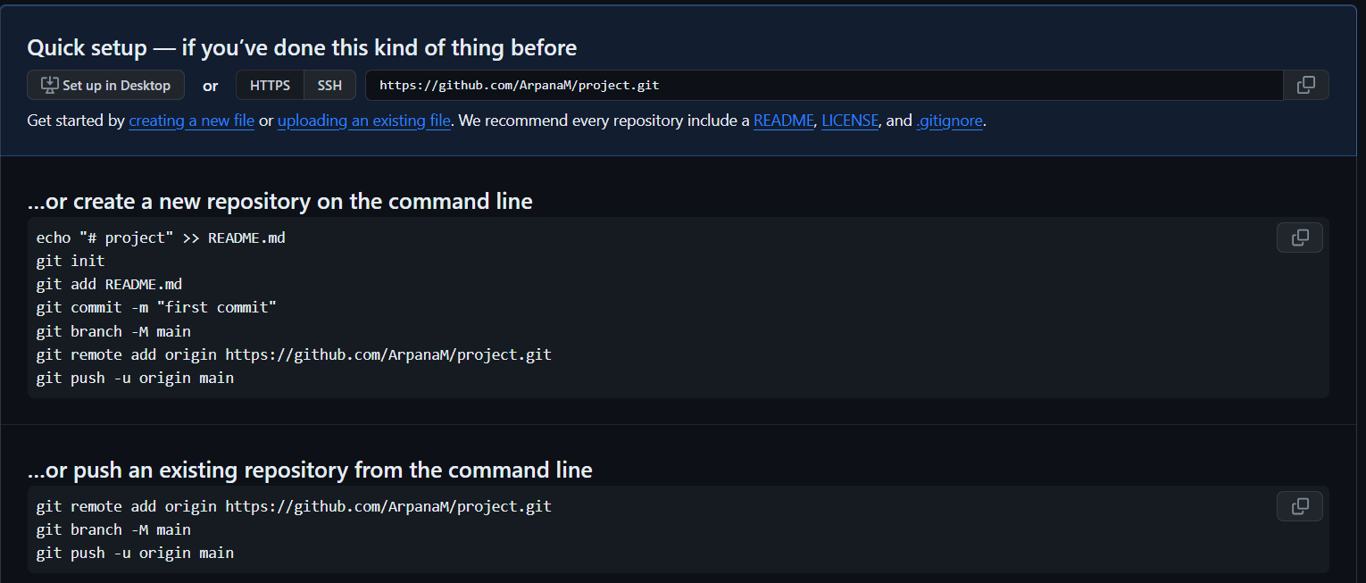

1. convert the local directory into a Git repository

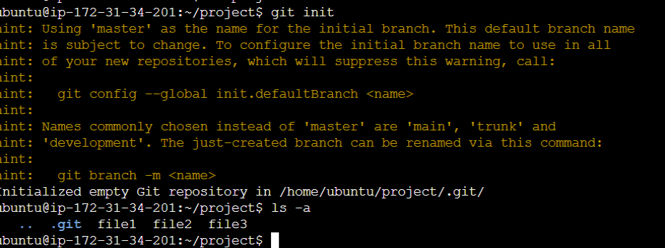

1. files moves to staging area

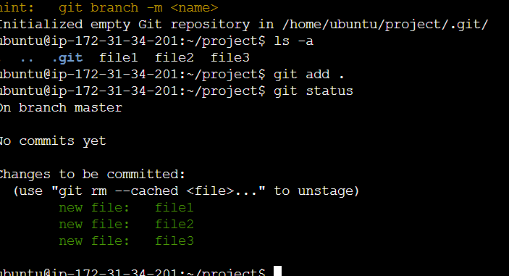

No link created to Github Repo

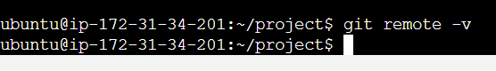

Authenticate to Github

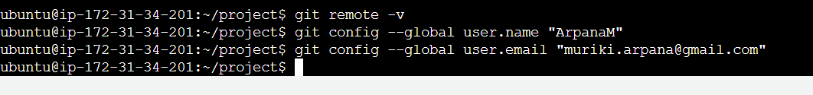

Commited file

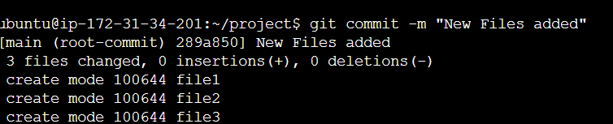

1. link it to GitHub to push the code into the repository.

